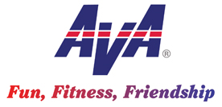
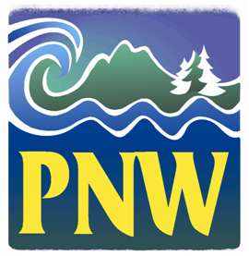
Hello NW Volkssporters!

1. RD/DRD Election. Louise Dix, President of the Oregon State Volkssport Association, is heading the region’s nominating committee for the Regional Director and Deputy RD election for the 2019-21 term. Committee members include Jim Westcott, Willamette Wanderers; Bob Hall, All Weather Walkers; Mike Medolo, Anchorage Volkssport Club; and Helen Ross, Pathfinder Club. Please canvas all club members to ask interested candidates to forward their name and letter of qualifications to one of the committee members by the end of November. Candidates for the positions will be presented to the clubs for voting in December/January, with final decision by 1 February 2019.

2. AVA officer nominations. Candidates are being sought for AVA President, Vice President, Secretary and Treasurer. The process is spelled out in the November Checkpoint. If interested, please consult the guidance in Checkpoint and submit your application. At least two positions are vacating—Secretary and Treasurer—and we need qualified replacements for those positions.

3. Awards. The November Checkpoint also invites us to nominate qualified individuals for four national awards. Nominations were due to me at the beginning of November, but I can work to the end of the month to finalize nominations. Also available is the President’s Award which can be sent directly to the AVA President. Contact me if you have any questions or nominations to offer.

4. Convention 2019. This past week I had an opportunity to visit Albany NY and meet with the local committee working on the convention. They are working very diligently to make this a spectacular event and national meeting. While in NY Louise and I took in several great walks south of Albany at and around West Point. The area is rich in America’s history and the Hudson River Valley is stunning. You won’t want to miss this convention. We traveled out and back with Southwest Airlines and had great connections from Portland through Chicago to/from Albany.

5. The American Wanderer (TAW) Issues Reduced. Your AVA Board voted to have the TAW published quarterly instead of every two month starting next year. This will result in a savings of $8,000 per year to AVA. For clubs advertising events through the TAW you’ll need to plan a little further out to meet your deadlines.

6. Rogue Valley Riches Moved to 2020. Because our calendar in 2019 got too crowded, the Rogue Valley Walkers decided to shift their event to June 2020. The weekend of 17-19 May 2019 is available for event scheduling.

7. Canadian Convention 2020. Think Yellowknife, Northwest Territory in early June 2020 on the north shore of Great Slave Lake. This will be a chance to get within 250 miles of the Arctic Circle and do some great walks with our Canadian friends.

Happy Trails!

Tom Baltes, NW Regional Director, 505-298-1256, TLBaltes@aol.com

