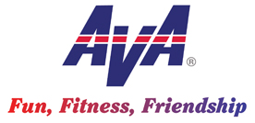
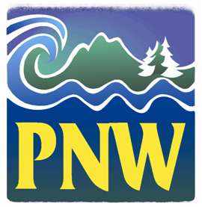
Hello NW Volkssporters!

1. Cancelled Event. The CRVC Christmas Ships Walk for 15 Dec is cancelled, as the starting point became unavailable at the last minute.

2. GroupWorks. If you are a club or state officer you should have been invited into a free program offered by GroupWorks. It is a very promising platform for internal and external communication for club, state and higher business, as well as advertising our events. I encourage everyone to give it a try and see how we can integrate it into our existing web of communications modes. They have provided training through several webinars and will be attending our convention in Albany to continue the training on their program.

3. AVA Coupons. A motion was put forward by several northwest club officers to request that clubs no longer need to send in coupons; merely report coupon count on the after action report. This motion was discussed this week by the Board and there was general consensus that they aren’t needed for financial accounting, which is an Executive Director’s call. However, discussion centered on the fact that they include valuable information about new walkers and we at the club, state, region and/or national level should be using the data to help engage new walkers. More discussion to follow and in the meantime continue to submit by mail or scan and email the coupons.

4. Monthly Meeting Minutes. The Board minutes are published on the AVA website under the Administrative button, then General Admin and Current NEC Minutes. I try to hit the highlights in my monthly Walk Talk, but more details are in those minutes.

5. Convention Voting and Attendance. By now I hope your club is discussing who will attend the convention and vote on your behalf. As always there are important votes, such as who will serve as national Board officers, financial issues and where our program is headed. Each club should be represented and I encourage all our walkers to consider attending this exceptional venue of great walks, fun social events and engaging workshops. There will be something for all of us in Albany next June.

6. Convention Registration. Pre-registration will be opening soon; hopefully before the year end. Keep checking the AVA website and links to the convention. Once open register so the convention committee can begin to get a sense of the attendance level.

Happy Holidays and be safe if you’re traveling!

Tom Baltes, NW Regional Director, 505-298-1256, TLBaltes@aol.com

