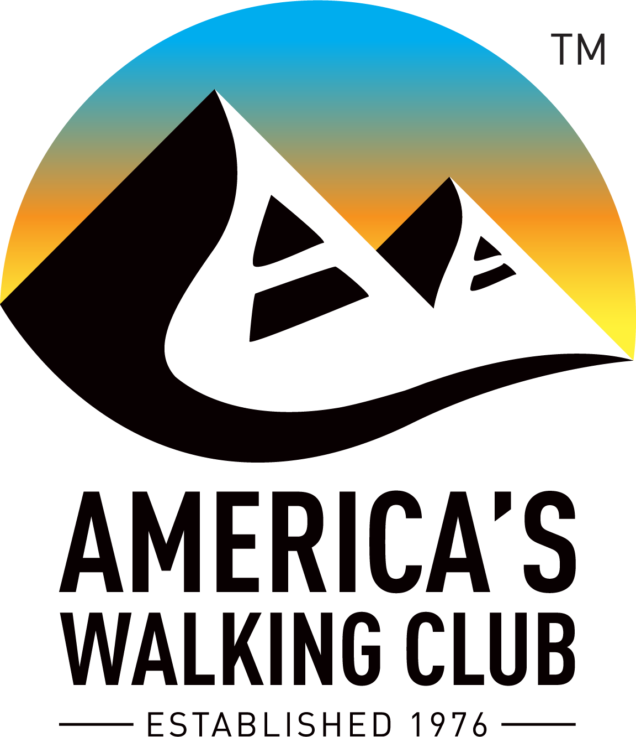
Hello NW Volkssporters!

Thomas Edison said: “Great ideas originate in the muscles.” I infer this to mean take a walk to open your mind to new idea. Works for me!

1. Regional Conference Postponed to 20-23 May 2021. The conference committee conceded that a June conference was not supportable, so we originally planned to postpone to 6-9 May 2021; however, the conference hotel subsequently asked us to move to a different date and we agreed to 20-23 May 2021. The new dates are actually better for walking conditions on some trails and allow more preparation time following several April events.

2. Virtual Online Program (VOP) T-shirt. For those who registered for the Appalachian Trail virtual walk this year you will receive a commemorative T-shirt. As a donation, I invite you to consider foregoing the T-shirt. It will be a cost savings for AVA and reduce the staff time involved in handling the shipments. Louise and I have plenty T-shirts and are happy to make this a donation for 2020. Contact Marian at AVA if you decide to skip the T-shirt, otherwise no action needed and enjoy the prize for your virtual walk.

3. C-19 VOP Offer. So far 25 walkers have registered for the special COVID-19 virtual program to allow you to convert alternate activities to steps because of our stay-at-home orders. This is another fun way to earn credit for all the active things you do, so consider signing up for this alternative program.

4. YRE Start Box Options. This month the AVA Board approved a motion to allow clubs to host their year round/seasonal walks in any or all of the three ways available—walkbox at the location, online startbox and/or remote registration done by (e)mail. In light of the closure of so many start locations it is now clear we need more flexibility in our registration alternatives for nearly all our walks. If you choose to offer multiple alternatives ensure you edit the event sanction listing to reflect the alternatives.

5. Big Give—Walk Long, Walk Strong. You’ll see on the AVA webpage that we’re more than half way to the goal and donations can be made all the way through to the new date of September 10. If you’re still on the fence about giving, know that every donation, big or small, will be especially helpful this year.

6. Quarterly Reports. There are still a few clubs pending, so please get the reports filed. Again, if no data available you still need to enter zeroes or an estimate for each YRE to submit your reports.

7. AVA Convention Hotel. There are already 400 of the 500 rooms reserved at the Madison Concourse Hotel obligated, so lock in your room soon. Details for registering are on the AVA website or in the April Checkpoint newsletter.

8. When Can We Resume Walking? Within the guidelines of social distancing I hope most of you are still walking and recording your participation. Our AVA President, David Bonewitz, just issued new guidance, but essentially, we must operate in compliance with the most restrictive guidance from fed/state/local leaders. The federal three phase plan is the framework our states will use and that will dictate when we can resume Traditional Events and larger group walks. There may be some wide variability across our four states, so I’m depending on club leaders to make those judgment calls on when to resume.

9. TE Postponements to 2021. Be aware that if we have Traditional Events postponed from 2020 to 2021 we need to communicate that information to Hector at AVA, as he’ll have to adjust the stamp in the database to reflect the correct year. All other data will be the same on the stamp.

10. AVA Special Programs/Challenges. In light of the COVID-19 impacts, Special Programs and Challenges are being looked at for extensions for completion. If you have any concerns about completing any please let me know.

11. AVA Budget Update. Henry and Erin have worked diligently to reflect COVID-19 impacts in a revised 2020 budget and to reduce staff payroll and spending. The Mass Marketing contract is on hold with $77k still available. Erin also reported that she has applied for the Paycheck Protection Program, which could be a big boost if granted. The Board deferred the July in-person meeting in Madison WI saving approximately $10k. On the other side of the ledger revenues are expected to be significantly lower with Crazy Horse cancelled, along with many other Traditional Events and far fewer walkers on Year Round Events.

12. AVA Convention Survey. Many of you may have seen an email from Hector regarding a convention survey. If you’re planning to attend the convention please take the survey. The Training and Convention Committees are working diligently to focus their workshop plans to meet your needs. Here’s the link to the survey: https://www.surveymonkey.com/r/HW3MGH3

13. AVA Tutorials: There are four current tutorials on the my.ava.org page. After opening my.ava.org click on “Find a…” at the top and then “Tutorial” on the next page. You’ll find assistance on: 1) AVA Trail and Route rating system, 2) Assembling the new stamps, 3) Adding AVA sanction details to your club web site, and 4) Adding a status message or alert to your event. As time progresses I expect more lessons to follow.

14. Event Status: For clubs there’s a new Status option available to reflect any changes in walk availability. From the club login on my.ava.org select “Sanctions”, then select “Status”, and from there you can edit each of your events. See item 13. above about a tutorial to learn more about adding status messages.

15. Thanks State/Club Leadership: Across our region we have the greatest group of volunteer leaders you’ll find in any corner of the country. I want to offer special thanks to the ESVA leadership team completing their term and those who are stepping up for the next 2 years. You’re all awesome!

16. Start Point Etiquette. In the ESVA meeting this past weekend we had a good discussion about the need to be more courteous around our walkbox hosts when registering groups. When possible, move the walkbox outside, don’t congregate in the business area, use public restrooms, practice good social distancing and limit touching of stamps/pens/logs/etc. As always, go out of your way to thank our hosts for their support. Now is a good time to request a Certificate of Appreciation for your walkbox hosts to let them know they are vital to our program and much appreciated. I can produce them in a matter of days.

Uncle John’s Bathroom Reader, Plunges Into The Universe 2002 edition, page 412 cites: “What they provide us: sheep—insulin; cows—smallpox vaccines; horses—serums for tetanus shots”. Makes me wonder what critter will provide the coronavirus vaccine—donkey, elephant or both together?

Happy Trails! Tom Baltes, NW Regional Director, 505-298-1256, TLBaltes@aol.com

