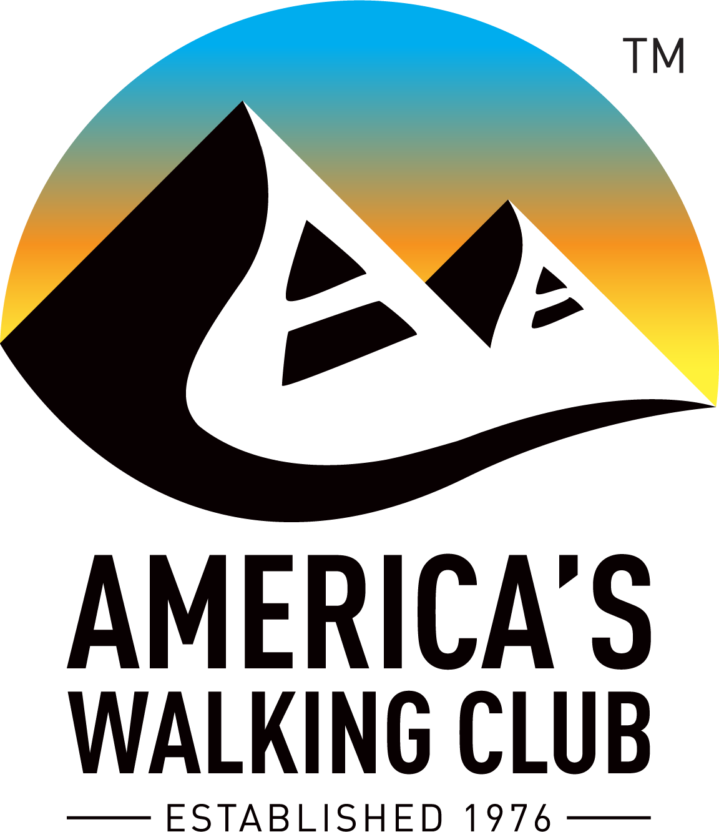
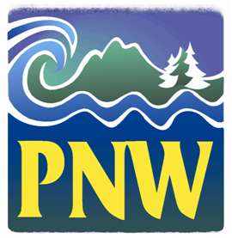
Hello NW Volkssporters!

“Life’s most persistent and urgent question is, ‘What are you doing for others?’” Martin Luther King, Jr.

1. COVID-19 Era Walk Procedures. After conferring with our state association presidents and vice-presidents, we’ve adopted some basic recommendations for safe procedures to follow in group walks until we’re beyond the threat of the coronavirus. The May AVA Checkpoint newsletter had a list of best practices on page three that we endorse. Following the state and local restrictions where the walk occurs is paramount. For now, we suggest several variances from the AVA procedures:

- Masks should be worn at registration and carried on the walk to be worn in areas where social distancing can’t be reasonably maintained.
- It’s best to ask all participants bring their own water and snacks.
- Our state web sites will have a form with images of a standard start card that we recommend you have walkers fill out in advance and bring to the walk. Have the walkers deposit the card in a container and have a volunteer record the walkers’ names on a registration form.
- Advise walkers to bring exact fees for the walk and deposit the money in a separate container.
- Walkers should be advised to bring their own pen to sign any forms or fill out their achievement books.
- Have one volunteer with mask and gloves dedicated to stamping achievement books.

2. Yellowknife hotel. As a friendly reminder, if you had a reservation with the Chateau Nova in Yellowknife and aren’t sure you cancelled the reservation you might want to call them to confirm. The conference was schedule to start this week, so cancel immediately. A member of the region was recently in touch with the hotel and the Chateau Nova staff indicated they still have many attendees who haven’t cancelled.

3. OSB tutorial in TAW. On the last page of The American Wanderer there’s a great tutorial on how to register for the Online Start Box (OSB). More and more of our walks are being added to the OSB, so it’s increasingly important for walkers to learn to use the OSB.

4. YouTube AVA videos. Several educational videos have been added to YouTube about our program. To see them open youtube.com and search for America’s Walking Club. These are three topics to see now:

Come Walk With Us!: https://www.youtube.com/watch?v=Hvh4i0gKWbs

Safety Guidelines video: https://www.youtube.com/watch?v=LSmln8M9ak4

Walk long, walk strong: https://www.youtube.com/watch?v=UvGaExVmGBE

“I will not follow where the path may lead, but I will go where there is no path, and I will leave a trail.” Muriel Strode

Happy Trails! Tom Baltes, NW Regional Director, 505-298-1256, TLBaltes@aol.com

