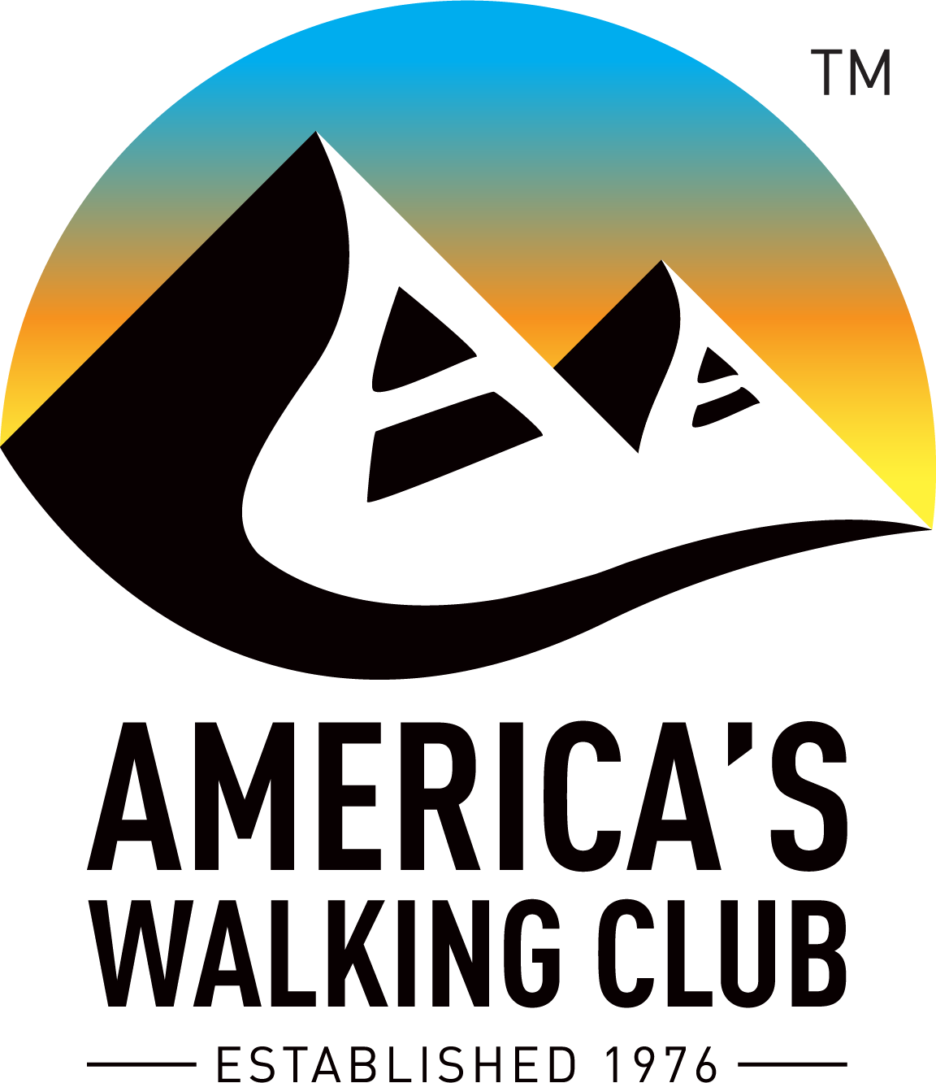
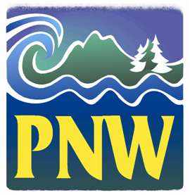
Hello NW Volkssporters!

“The world is a book and those who do not travel read only a page.” St Augustine
I would add: those who travel and don’t walk read only the first paragraph of each chapter.

1. Walks Online: Many clubs have begun to add their Year Round/Seasonal Events to the Online Startbox (OSB) to give you more and safer options to participate in walks. As an example, the Olympic Peninsula Explorers and Capitol Volkssport Club have nearly all their walks online as well as physical start boxes in most cases. To use the OSB option you have to have an account through my.ava.org shown here and select “New Account” or “Login” if you have an account.

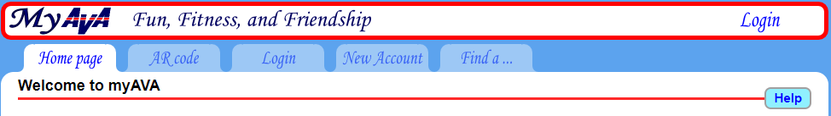
When participating through the OSB you will first register, pay $2 and be given access to download the walk directions and map. Don’t forget to complete the final step of indicating you finished the walk after you’re done, as our clubs will not receive their credit for your participation until that step is done. Some walkers may elect to complete that step immediately after registering and I believe that would be fine.

2. New Stamp Image Process. Forwarded with this Walk Talk you’ll find a step by step process for clubs to generate stamp images on a .pdf file. This new capability allows clubs to produce images of walk stamps to be emailed or mailed to walkers instead of stamping and mailing insert cards. This is a very timely option with many walkboxes unavailable due to COVID restrictions and also in support of many walks with remote start points.

3. Smaller Groups, Better Safety: Several clubs have or will soon conduct Traveling Guided Walks. The principal feedback I’ve received is that locating available bathrooms is vital to a pleasant experience and that maintaining physical distance during the walks has been challenging. My expectation of walk hosts is that they will promote safe procedures in compliance with local, state and federal guidelines. Once the walk starts the burden falls to each participant to manage physical distancing on the trail and don a mask when needed. Selecting routes with little competing traffic will help and keeping our group sizes smaller are better choices until infection rates start to decline again.

4. Nancy Smith Shirts: Many of you know Nancy Smith, our wonderfully creative shirt sales person who supports many of our larger events. Like many small businesses, she has been unable to market her shirts at any events for most of this year. You can find her apparel at www.nancyjsmith.com and we’ll look forward to seeing her at the Regional Conference next summer.

5. Marketing our Sport: Now seems to be an incredibly opportune time to market our sport, with so many Americans rediscovering the benefits of walking. Unfortunately, some belt tightening at the national office has suspended the marketing contract work until conditions improve and we’re not very visible with the closure of many start points and postponement of our Traditional Events. My challenge to everyone in the region is to find ways to sell our program. Write an article for your local paper, they’re starving for upbeat material; talk up America’s Walking Club with people you see on a trail; wear your club shirts when you’re out walking to start conversations; and promote walking to your families and friends across the country.

6. YRE Renewals for 2021: We’re in the window for you to begin renewing Year Round and Seasonal Events for 2021. Clubs have until 15 September to renew your events and I have until the end of September to review the nearly 400 submissions. It’s a difficult year to be certain what to do, but do your best and complete your submissions as early as you can. There are some important tips in the latest Checkpoint newsletter that you should review.

7. Event Status Changes. Several clubs have asked me what they need to do to get the word out about changes in walk status. The most critical step is to reflect the change in the AVA Sanction System. There are newer features in my.ava.org for reflecting status that I encourage you to use. However, you should also edit the event sanction in the Legacy system with notes in the Comments section or other areas to draw attention to closures/reopening/changes in start point/etc. Be sure to use club newsletters and emails to get the word to those who are most like to walk your events. You can also forward information to Wendy Bumgardner for the walkwashington and walkoregon email blasts she manages. By the way, if you aren’t registered for her emails you can register here: walkwashington-subscribe@yahoogroups.com or walkoregon-subscribe@yahoogroups.com. If the information needs to be edited in the Pathfinder be sure to contact Chase Davis. Don’t overlook the opportunity to write an article for The American Wanderer, especially for walks many outsiders might value, such as our capitol walks or walks supporting other AVA Challenges.

8. Club Officers: If you’ve elected new club officers this summer please forward their names and emails so I can add them to my email listing. Also update your club data on the AVA website. If you’ve stepped down from a leadership position and don’t want to continue receiving emails let me know and I’ll remove you from the email groups.

9. Board Meeting: The latest Checkpoint has information on how guests can log in to the July 10 and 11 online board meeting. We have a full plate of reports to review and topics to discuss. There will be limited opportunity for guests to ask questions or make comments, just as would be true at the in-person board meetings.

Happy Trails! Tom Baltes, NW Regional Director, 505-298-1256, TLBaltes@aol.com

